GROUPWORK: DESCRIPTION/PROCESSES WHEN PREPARING PYTHON ENVIRONMENT
CLASS: L5 NIT
GROUP MEMBERS:
      - NSHIMIYIMANA HIRWA Beni
      - IGIRIMPUHWE Dieudonne
      - CYUSA Arnold

Step1: Download python
- Visit the official python website through your web browser: python.org
- Click” downloads” to find the right version according to your OS, may be Windows, Linux or macOS.
- Then Download.
Step2: Setup installation
- During installation on windows, tick the two boxes for easy running of python within your command line.

- Then click “Install now”. 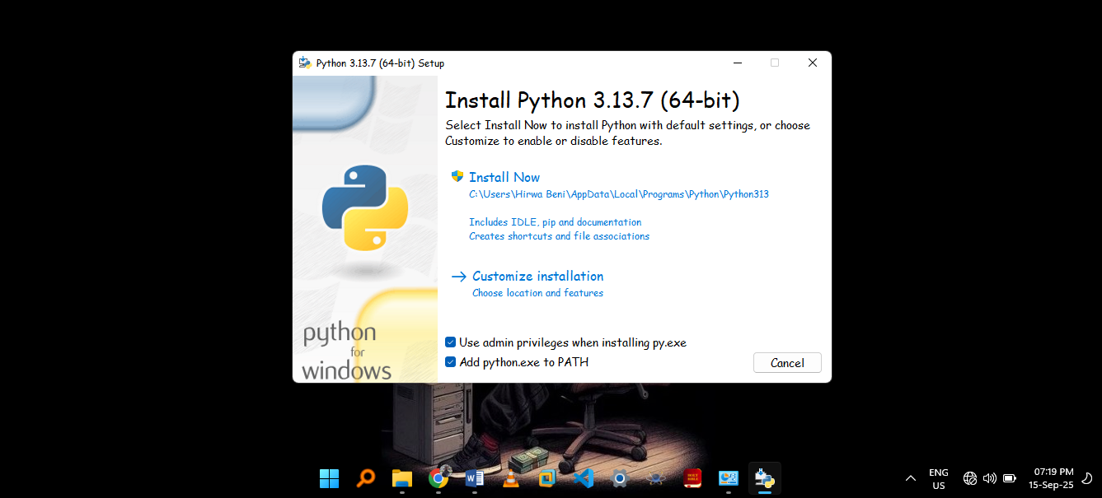
Step3: Verify the installation
- Open computer’s command line (CMD).
- Then type “python –version” and press Enter.
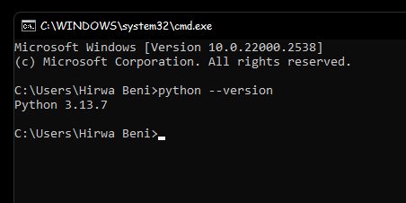
Step4: Testing by use of a simple program.

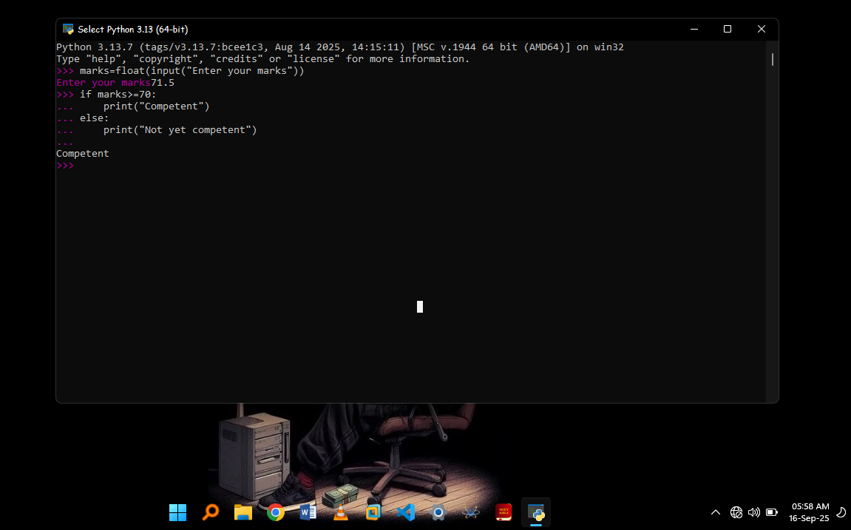
- Above is the simple program for checking if a student is competent or not yet competent.

THANKS!

